2. Over the past 10 years, the following statistics were observed for three investment options:
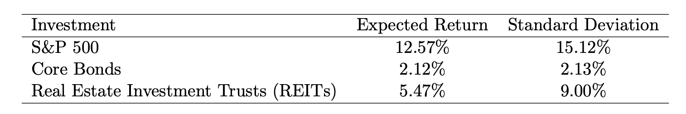
The correlations between the investments are:

ρS&P, Bonds=−0.32, ρS&P, REITs = 0.74, ρBonds, REITs=−0.04

(a) Construct a portfolio that is 50% in S&P 500 and 50% in REITs. Compute the expected
return and standard deviation of this portfolio.

(b) Construct a portfolio that is 50% in Core Bonds and 50% in REITs. Compute the
expected return and standard deviation of this portfolio.

(c) Construct a portfolio that is 80% in Core Bonds and 20% in REITs. Compute the
expected return and standard deviation of this portfolio.

(d) Based on your results, which portfolio would you recommend to an aggressive investor?
Which would you recommend to a conservative investor? Justify your answer.

Answer:

It’s given that:
ρS&P, Bonds = −0.32,
ρS&P, REITs = 0.74,
ρBonds, REITs = −0.04

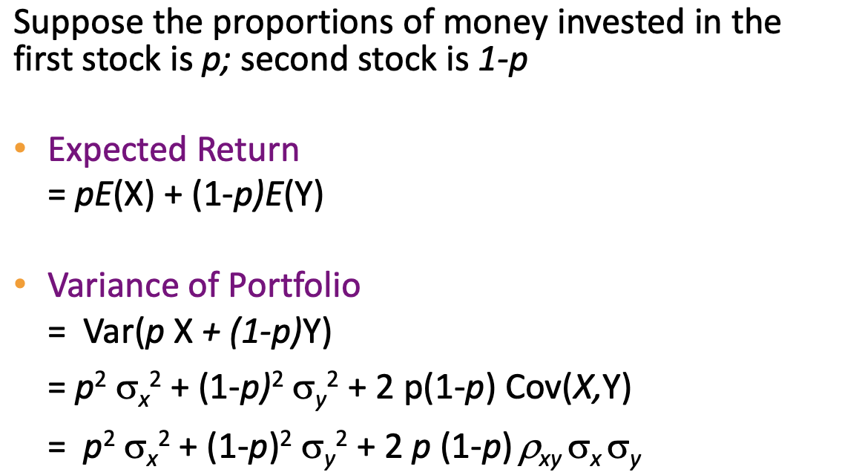

- portfolio that is 50% in S&P 500 and 50% in REITs:

Expected return = 50% * E(S&P 500) + (1-50%) * E(REITs) = 50% * 12.57% + 50% * 5.47% = 9.02%
Variance:
(50%)² * σ(S&P 500)² + (1-50%)² * σ(REITs) ² + 2 * 50% * (1-50%) * ρS&P, REITs * σ(S&P 500) * σ(REITs)
= (0.5)² * (15.12/100)² + (1-0.5)² * (9/100) ² + 2 * 0.5 * (1-0.5) * 0.74 * (15.12/100) * (9/100) = 1.28%
Standard Deviation = square root of 1.28% = 11.30%

- portfolio that is 50% in Core Bonds and 50% in REITs:
Expected return = 50% * E(Core Bonds) + (1-50%) * E(REITs) = 50% * 2.12% + 50% * 5.47% = 3.80%
Variance:
(50%)² * σ(Bonds)² + (1-50%)² * σ(REITs) ² + 2 * 50% * (1-50%) * ρBonds, REITs * σ(Bonds) * σ(REITs)
= (0.5)² * (2.13/100)² + (1-0.5)² * (9/100) ² + 2 * 0.5 * (1-0.5) * -0.04 * (2.13/100) * (9/100) = 0.21%
Standard Deviation = square root of 0.21% = 4.58%

- portfolio that is 80% in Core Bonds and 20% in REITs:
Expected return = 80% * E(Core Bonds) + (1-80%) * E(REITs) = 80% * 2.12% + 20% * 5.47% = 2.79%
Variance:
(50%)² * σ(Bonds)² + (1-50%)² * σ(REITs) ² + 2 * 50% * (1-50%) * ρBonds, REITs * σ(Bonds) * σ(REITs)
= (0.5)² * (2.13/100)² + (1-0.5)² * (9/100) ² + 2 * 0.5 * (1-0.5) * -0.04 * (2.13/100) * (9/100) = 0.06%
Standard Deviation = square root of 0.06% = 2.43%

- Recommendation:
  - For the Aggressive investor, the 50% S&P 500 and 50% REITs portfolio is suitable for higher risk tolerance, as it with the highest expected return (9.02%) with relatively high risk (11.3%)
  - For the Conservative investor, the 80% Core Bonds and 20% REITs portfolio is better suited for risk-averse investors seeking capital preservation, as it is with the lowest risk (2.43%) and modest return (2.79%).

3. According to a financial study, 18% of retail investors hold cryptocurrency in their investment
portfolios. Consider a randomly selected group of 25 retail investors.
- Compute the probability that exactly 7 investors hold cryptocurrency in their portfolios.
- Compute the probability that at least 10 of the investors hold cryptocurrency in their portfolios.
- Suppose you observed that 12 investors in the group hold cryptocurrency. Would this observation make you question the accuracy of the 18% figure? Explain your reasoning.
- If the first 5 investors in the sample are known to all hold cryptocurrency, what is the probability that exactly 7 investors in total hold cryptocurrency in the group of 25?

Answer:
Based on the given data, it’s a discrete distribution, and it follows a binomial distribution:
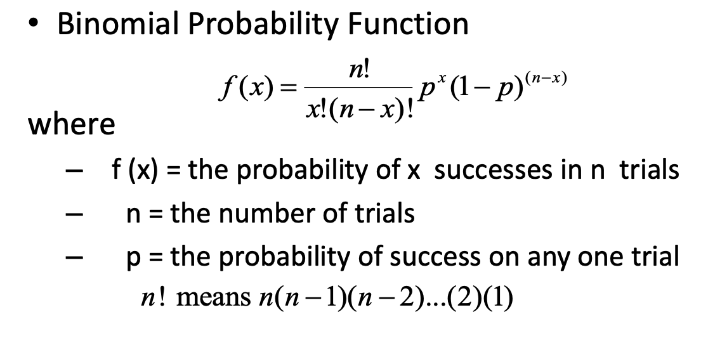

Here, n = 25 retail investors
p = 18% = 0.18 investors hold cryptocurrency in their portfolios

- Probability that exactly 7 investors hold cryptocurrency in their portfolios:
f(X = 7) = (25C7) * (0.18)⁷ * (1-0.18)⁽²⁵⁻⁷⁾ = 8.27%

- probability that at least 10 of the investors hold cryptocurrency in their portfolios:
f(X >= 10) = 1 – f(X<= 9)

f(X<= 9) is:
sum of f(X = 0), f(X = 1), f(X = 2), f(X = 3), f(X = 4), f(X = 5), f(X = 6), f(X = 7), f(X = 8), f(X = 9)

f(X = 0) = (25C0) * (0.18)⁰ * (1-0.18)⁽²⁵⁻⁰⁾ = 0.70%
f(X = 1) = (25C1) * (0.18)¹ * (1-0.18)⁽²⁵⁻¹⁾ = 3.84%
f(X = 2) = (25C2) * (0.18)² * (1-0.18)⁽²⁵⁻²⁾ = 10.12%
f(X = 3) = (25C3) * (0.18)³ * (1-0.18)⁽²⁵⁻³⁾ = 17.04%
f(X = 4) = (25C4) * (0.18)⁴ * (1-0.18)⁽²⁵⁻⁴⁾ = 20.57%
f(X = 5) = (25C5) * (0.18)⁵ * (1-0.18)⁽²⁵⁻⁵⁾ = 18.97%
f(X = 6) = (25C6) * (0.18)⁶ * (1-0.18)⁽²⁵⁻⁶⁾ = 13.88%
f(X = 7) = (25C7) * (0.18)⁷ * (1-0.18)⁽²⁵⁻⁷⁾ = 8.27%
f(X = 8) = (25C8) * (0.18)⁸ * (1-0.18)⁽²⁵⁻⁸⁾ = 4.08%
f(X = 9) = (25C9) * (0.18)⁹ * (1-0.18)⁽²⁵⁻⁹⁾ = 1.69%
So, P(X<=9) = 0.70% + 3.84% + 10.12% + 17.04% + 20.57% + 18.97% + 13.88% + 8.27% + 4.08% + 1.69% = 99.16%

P(X >= 10) = 1 – P(X <= 9) = 1 - 99.16% = 0.84%

- For X = 12 retail investors:
P(X = 12) = (25C12) * (0.18)¹² * (1-0.18)⁽²⁵⁻¹²⁾ = 0.05%
As the probability is very less, it seems the 12 investors in the group holding crypto is very unlikely with 18% accuracy. Hence, it raises the question of 18% accuracy.

- As it’s mentioned that the first 5 investors in the sample are known to all hold cryptocurrency, we need 2 more investors out of the remaining 25 – 5 = 20 investors.

So, P(X = 2) = (20C2) * (0.18)² * (1-0.18)⁽²⁰⁻²⁾ = 17.30%

So, the probability that exactly 7 investors in total hold cryptocurrency in the group of 25 based on the above condition is 17.30%

